Procedure for using Date Time Value Fix
1. Unzip the attached file which included three files
i. DrvModbus.exe
ii. PMC-630C Date Time Value.SNF
iii. PMC53M Date Time Value.SNF
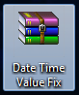
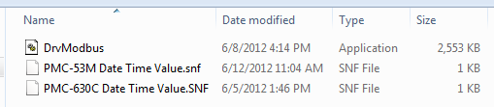

2. Copy the "DrvModbus.exe" and Replace the existing one in PecStar folder.
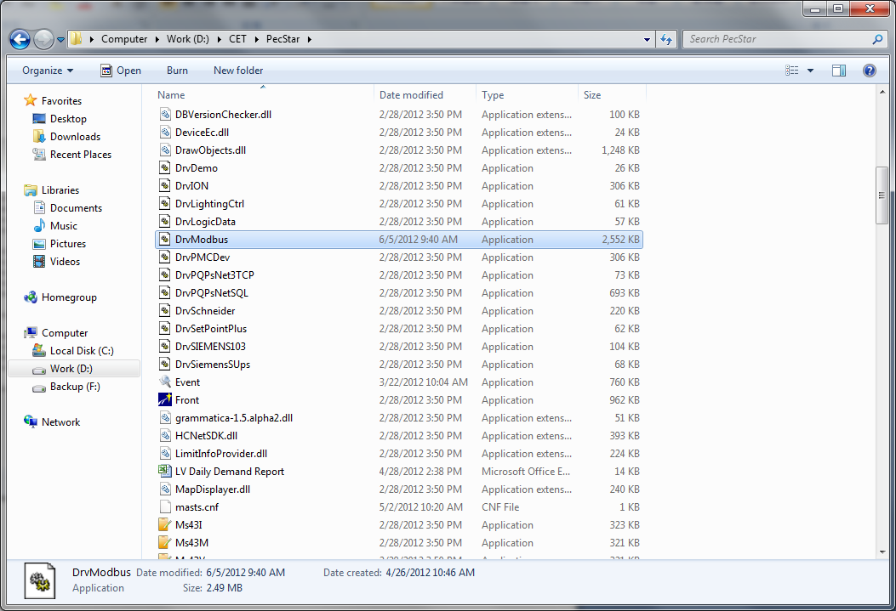
3. After replace the "DrvModbus.exe" file, open PecConfig and select the meter that you want to get the Hour Value.
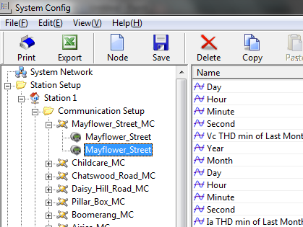
4. Scroll Down to the last AI point, you will get the point similar with the following screen.
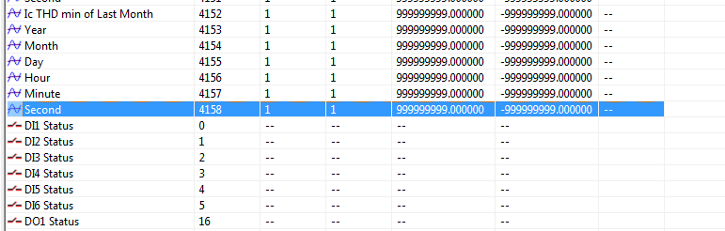
5. Right click on the selected Meter Name and click "Import SNF File"
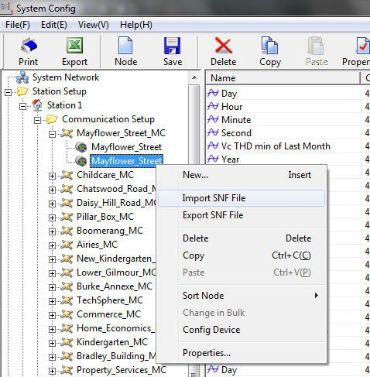

6. Select "PMC-630C Date Time Value.SNF" import the PecConfig.
7. Press "Yes" to confirm import action.
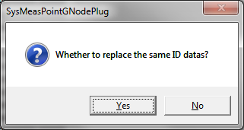
8. Scroll down and check whether the parameter success import to meter config.
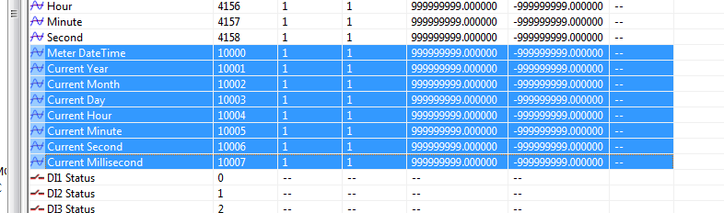
9. Save the Config and Use PecSCADA to check whether the Hour Value can be display.
